**Project Design Phase**

**Solution Architecture**

|  |  |
| --- | --- |
| Team ID | LTVIP2025TMID29763 |
| Project Name | Airline Management System |
| Maximum Marks | 4 Marks |

**Solution Architecture:**

The solution uses **Salesforce’s cloud ecosystem** to create a fully integrated airline management platform that streamlines passenger services, operations, and communication.

Its goals are to:

* **360° Customer View**  
  Centralize traveler data from booking to post-flight, enabling better service and personalization..
* **Automation of Airline Operations**  
  Automate frequent tasks like ticket reissuance, flight reminders, delay alerts, etc.
* **Scalability and Flexibility**  
  Easily scale operations across routes, regions, and customer segments without rebuilding the system.
* **Enhanced Customer Experience**  
  Faster issue resolution, personalized travel suggestions, real-time updates, and loyalty tracking.

**Example - Solution Architecture Diagram:**

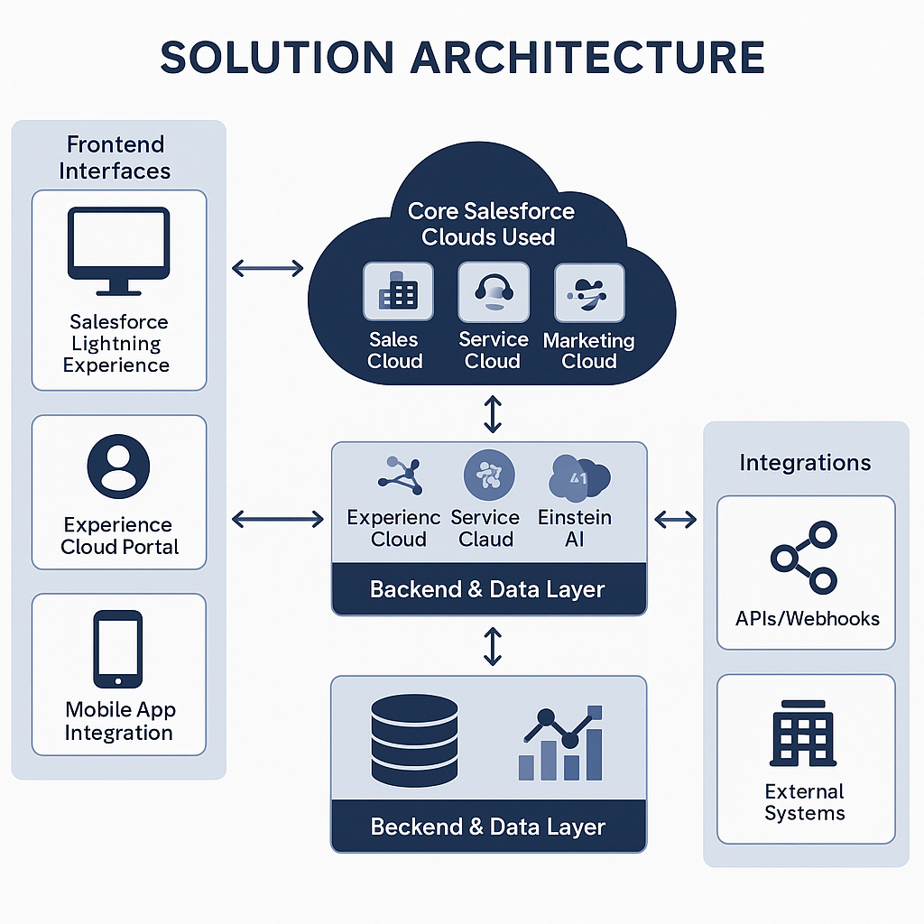

*Figure 1: Architecture for Airline Management System Project.*

**Reference:** [**https://aws.amazon.com/blogs/industries/voice-applications-in-clinical-research-powered-by-ai-on-aws-part-1-architecture-and-design-considerations/**](https://aws.amazon.com/blogs/industries/voice-applications-in-clinical-research-powered-by-ai-on-aws-part-1-architecture-and-design-considerations/)